Guidance for Topic 1 DQ 1

Note the pics here are from an older version of the template. The video embedded in the template shows the current sheet, and the formulas below are correct.
- First, make sure to enter your name in H2.

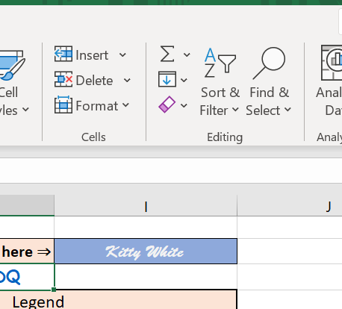

- Make sure to watch the video, and the next step is to enter the numbers in B8 and C8 and enter a formula in F8.

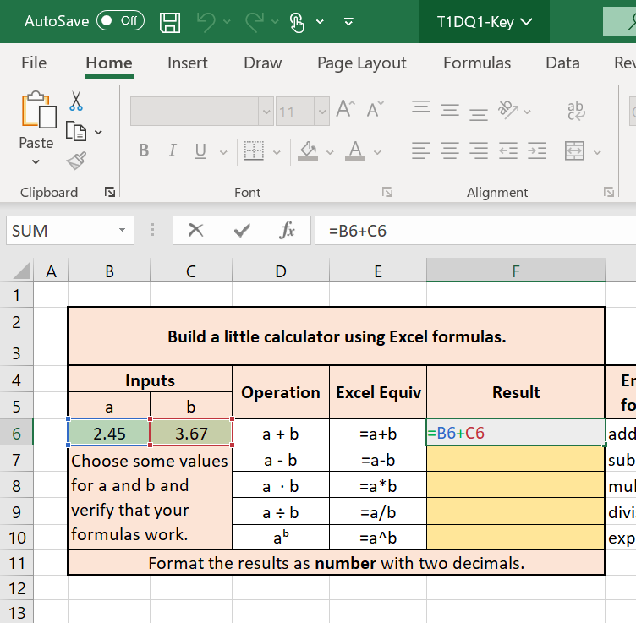

If you need to review how to use basic Excel functions, please review this instruction by Microsoft: https://support.microsoft.com/en-us/office/use-excel-as-your-calculator-a1abc057-ed11-443a-a635-68216555ad0a
- Next, highlight the answers and right-click them.

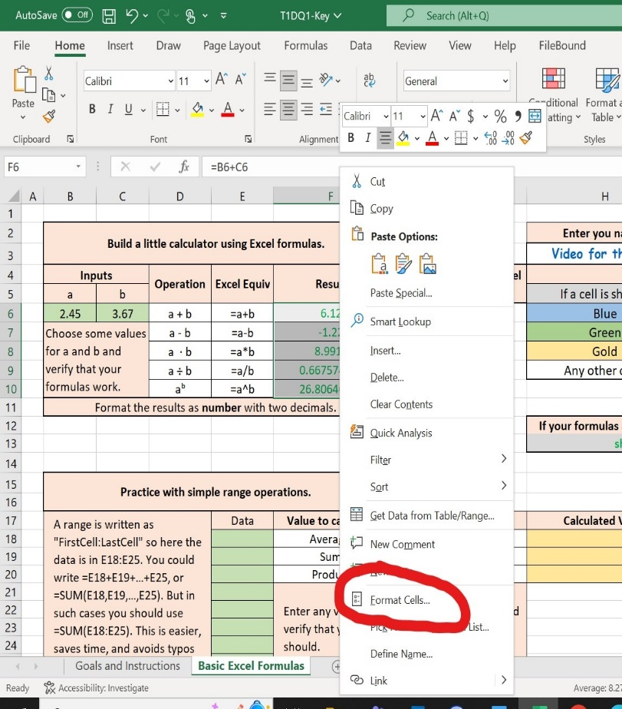

- Make sure to choose “Number” and “2” for decimal places.

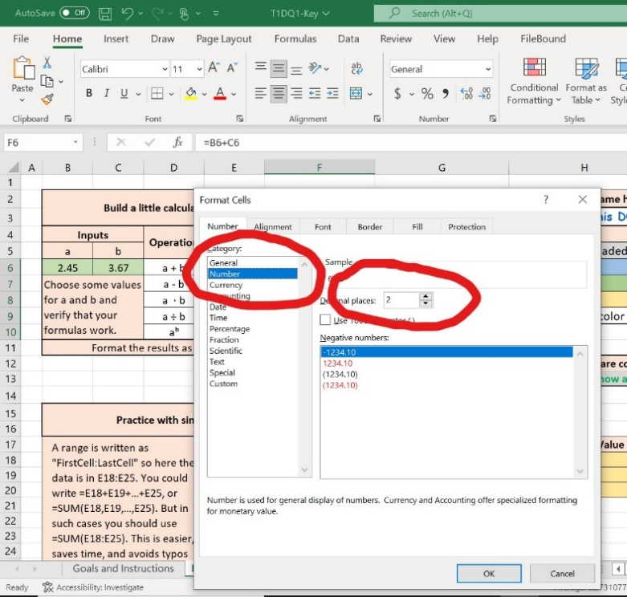

- Enter any numbers from E20 to E27 and practice entering Excel formulas from H20 to H22. Make sure to format the cells, as explained above, to set the number of decimals as indicated for each item. Note the formula in H20 should be =AVERAGE(E20:E27). (This differs from the image)

